PROFIT ANALYSIS USING REGRESSION PROJECT
Analysis Report

Submitted by: chilakala swathi
Tools used: MYSQL Microsoft excel Power BI
Data source: Database (MYSQL)

Objective
The objective of this project is to analyze how R&D spend, Administration spend, and Marketing spend affect startup profit using regression analysis. The project also predicts profit for given input values and visualizes insights using Power BI.

Problem statement
The objective of this project is to identify the impact of R&D spend, Marketing spend, and Administration spend on startup profit values using regression analysis.

Dataset description
The dataset contains information about 50 startups. It includes R&D spend, Administration, Marketing spend, state, and profit. The dataset was imported from MYSQL Database and used for regression analysis and profit prediction.
Total records: 50
Total columns: 5
Source: MYSQL Database

Data import and cleaning
The dataset was imported from MYSQL database into Power BI for analysis and visualization.
Data cleaning:
- Checked for missing values.
- Verified data types.
- Checked duplicate records.
- Validated numerical columns.
- Dataset was ready for analysis.

Regression analysis
Regression analysis was performed using Microsoft excel to identify the relationship between spending variables and profit.
Independent variables:
- RD_spend
- Administration
- Marketing_spend
Dependent variable:
- Profit

Regression output
The regression analysis was performed in Microsoft excel. The regression coefficient obtained from the model were used in Power BI to calculate predicted profit values.
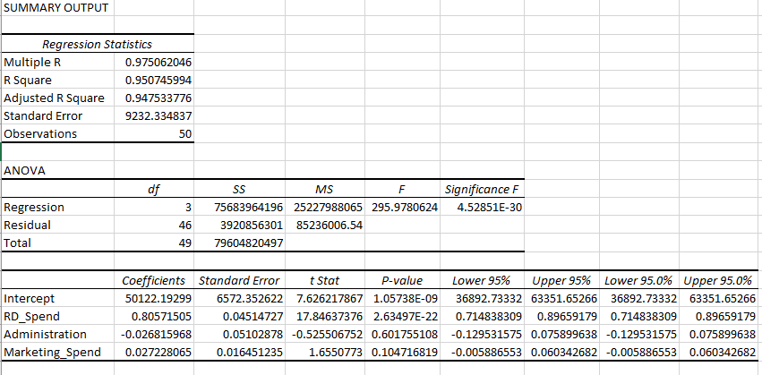
The regression coefficients indicate the contribution of each variable towards startup profit prediction.

Dax measures
DAX measures were created in Power BI to calculate key business metrics and predicted profit values.
- Total profit
- Average profit
- Total RD spend
- Total marketing spend
- Total administration spend
- Predicted profit 1
- Predicted profit2
Predicted profit 1 = 50122.19 + (0.8057 * 21892.92) – (0.0268 * 81910.77) + (0.0272 * 164270.70)
Predicted profit 2 = 50122.19 + (0.8057 * 23940.93) – (0.0268 * 96489.63) + (0.0272 * 137001.10)

Profit prediction
Profit prediction was performed using the regression coefficients obtained from the regression model. Predicted profit values were calculated using DAX measures in Power BI.
Prediction 1
RD_spend = 21892.92
Administration = 81910.77
Marketing_spend = 164270.70
Predicted profit = 70,034.27
Prediction 2
RD_spend = 23940.93
Administration = 96489.63
Marketing_spend = 137001.10
Predicted profit = 70,551.91

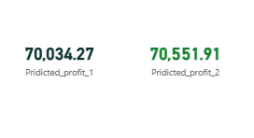

Dashboard visualizations
Power BI dashboards were created to visualize startup profit analysis, regression results, and predicted profit values.

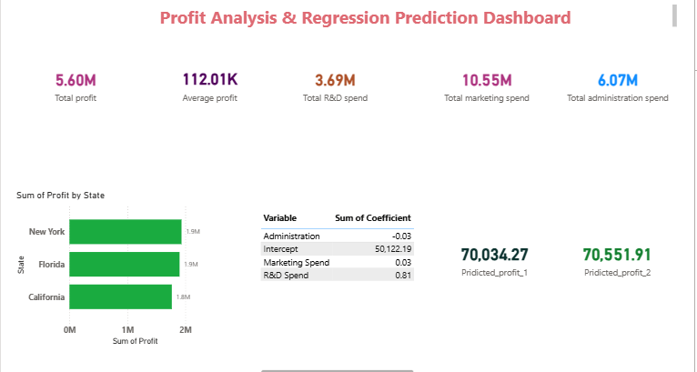

- KPI cards
- State wise profit Bar chart
- Regression coefficient table
- Predicted profit KPI cards

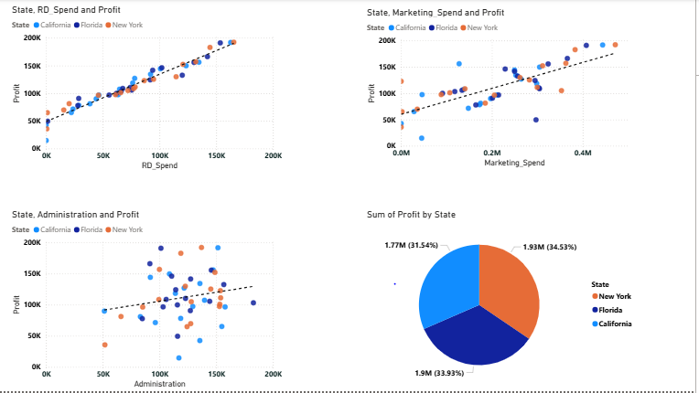
Regression analysis dashboard

- R&D spend vs profit scatter plot
- Marketing spend vs profit scatter plot
- Administration spend vs profit scatter plot
- Profit distribution pie chart

Key Insights
- R&D spend has the strongest positive impact on profit.
- Marketing spend has a moderate positive impact on profit.
- Administration spend has minimal impact on profit.
- Higher R&D investments generally result in higher profits.
- Predicted profits were successfully generated using regression coefficients

Suggestions
- increase investment in R&D activities to improve profitability.
- continue effective marketing activities to attract more customers and improve business growth.
- Monitor administrative expenses and avoid un necessary spending to improve profitability.
- Focus on innovation and product development.
- Use data analysis for decision making for future business planning.

Conclusion
The project successfully analyzed startup profit using regression analysis. Power BI dashboards were created to visualize the results and predicted profit values. The analysis revealed that R&D spend has the greatest impact on profit. The project provides valuable insights and recommendations for improving business performance.

